
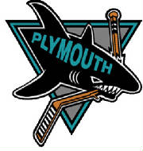
THE PLYMOUTH GREAT WHITE SHARKS MIN-MITE HOCKEY TEAM AND CARVEL ICE CREAM HAVE TEAMED UP FOR “GREAT WHITE SHARK DAY” AT CARVEL!!!!!!
THURSDAY JANUARY 4, 2007
PLEASE INVITE YOUR FAMILY, FRIENDS, AND CO-WORKERS TO VISIT CARVEL AT ANY TIME ON THURSDAY JANUARY 4TH. A PORTION OF THAT DAYS PROCEEDS WILL BE DOANTED TO THE SHARKS.

41990 Ford Road
Canton, MI 48187
(734) 983-9120
[ zoom out | zoom far out ]
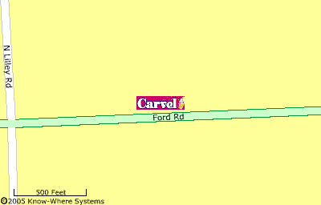

[ zoom in | zoom out ]
